edu_UL_2013_DY_tuhost_v_ohybu … Evaluate bending stiffness of a beam

Based on knowledge from the theory of the strenght of material:
Work of external forces is equal to work of internal forces
Depends on: Quadratic moment of inertia of the cross sectional area of the beam
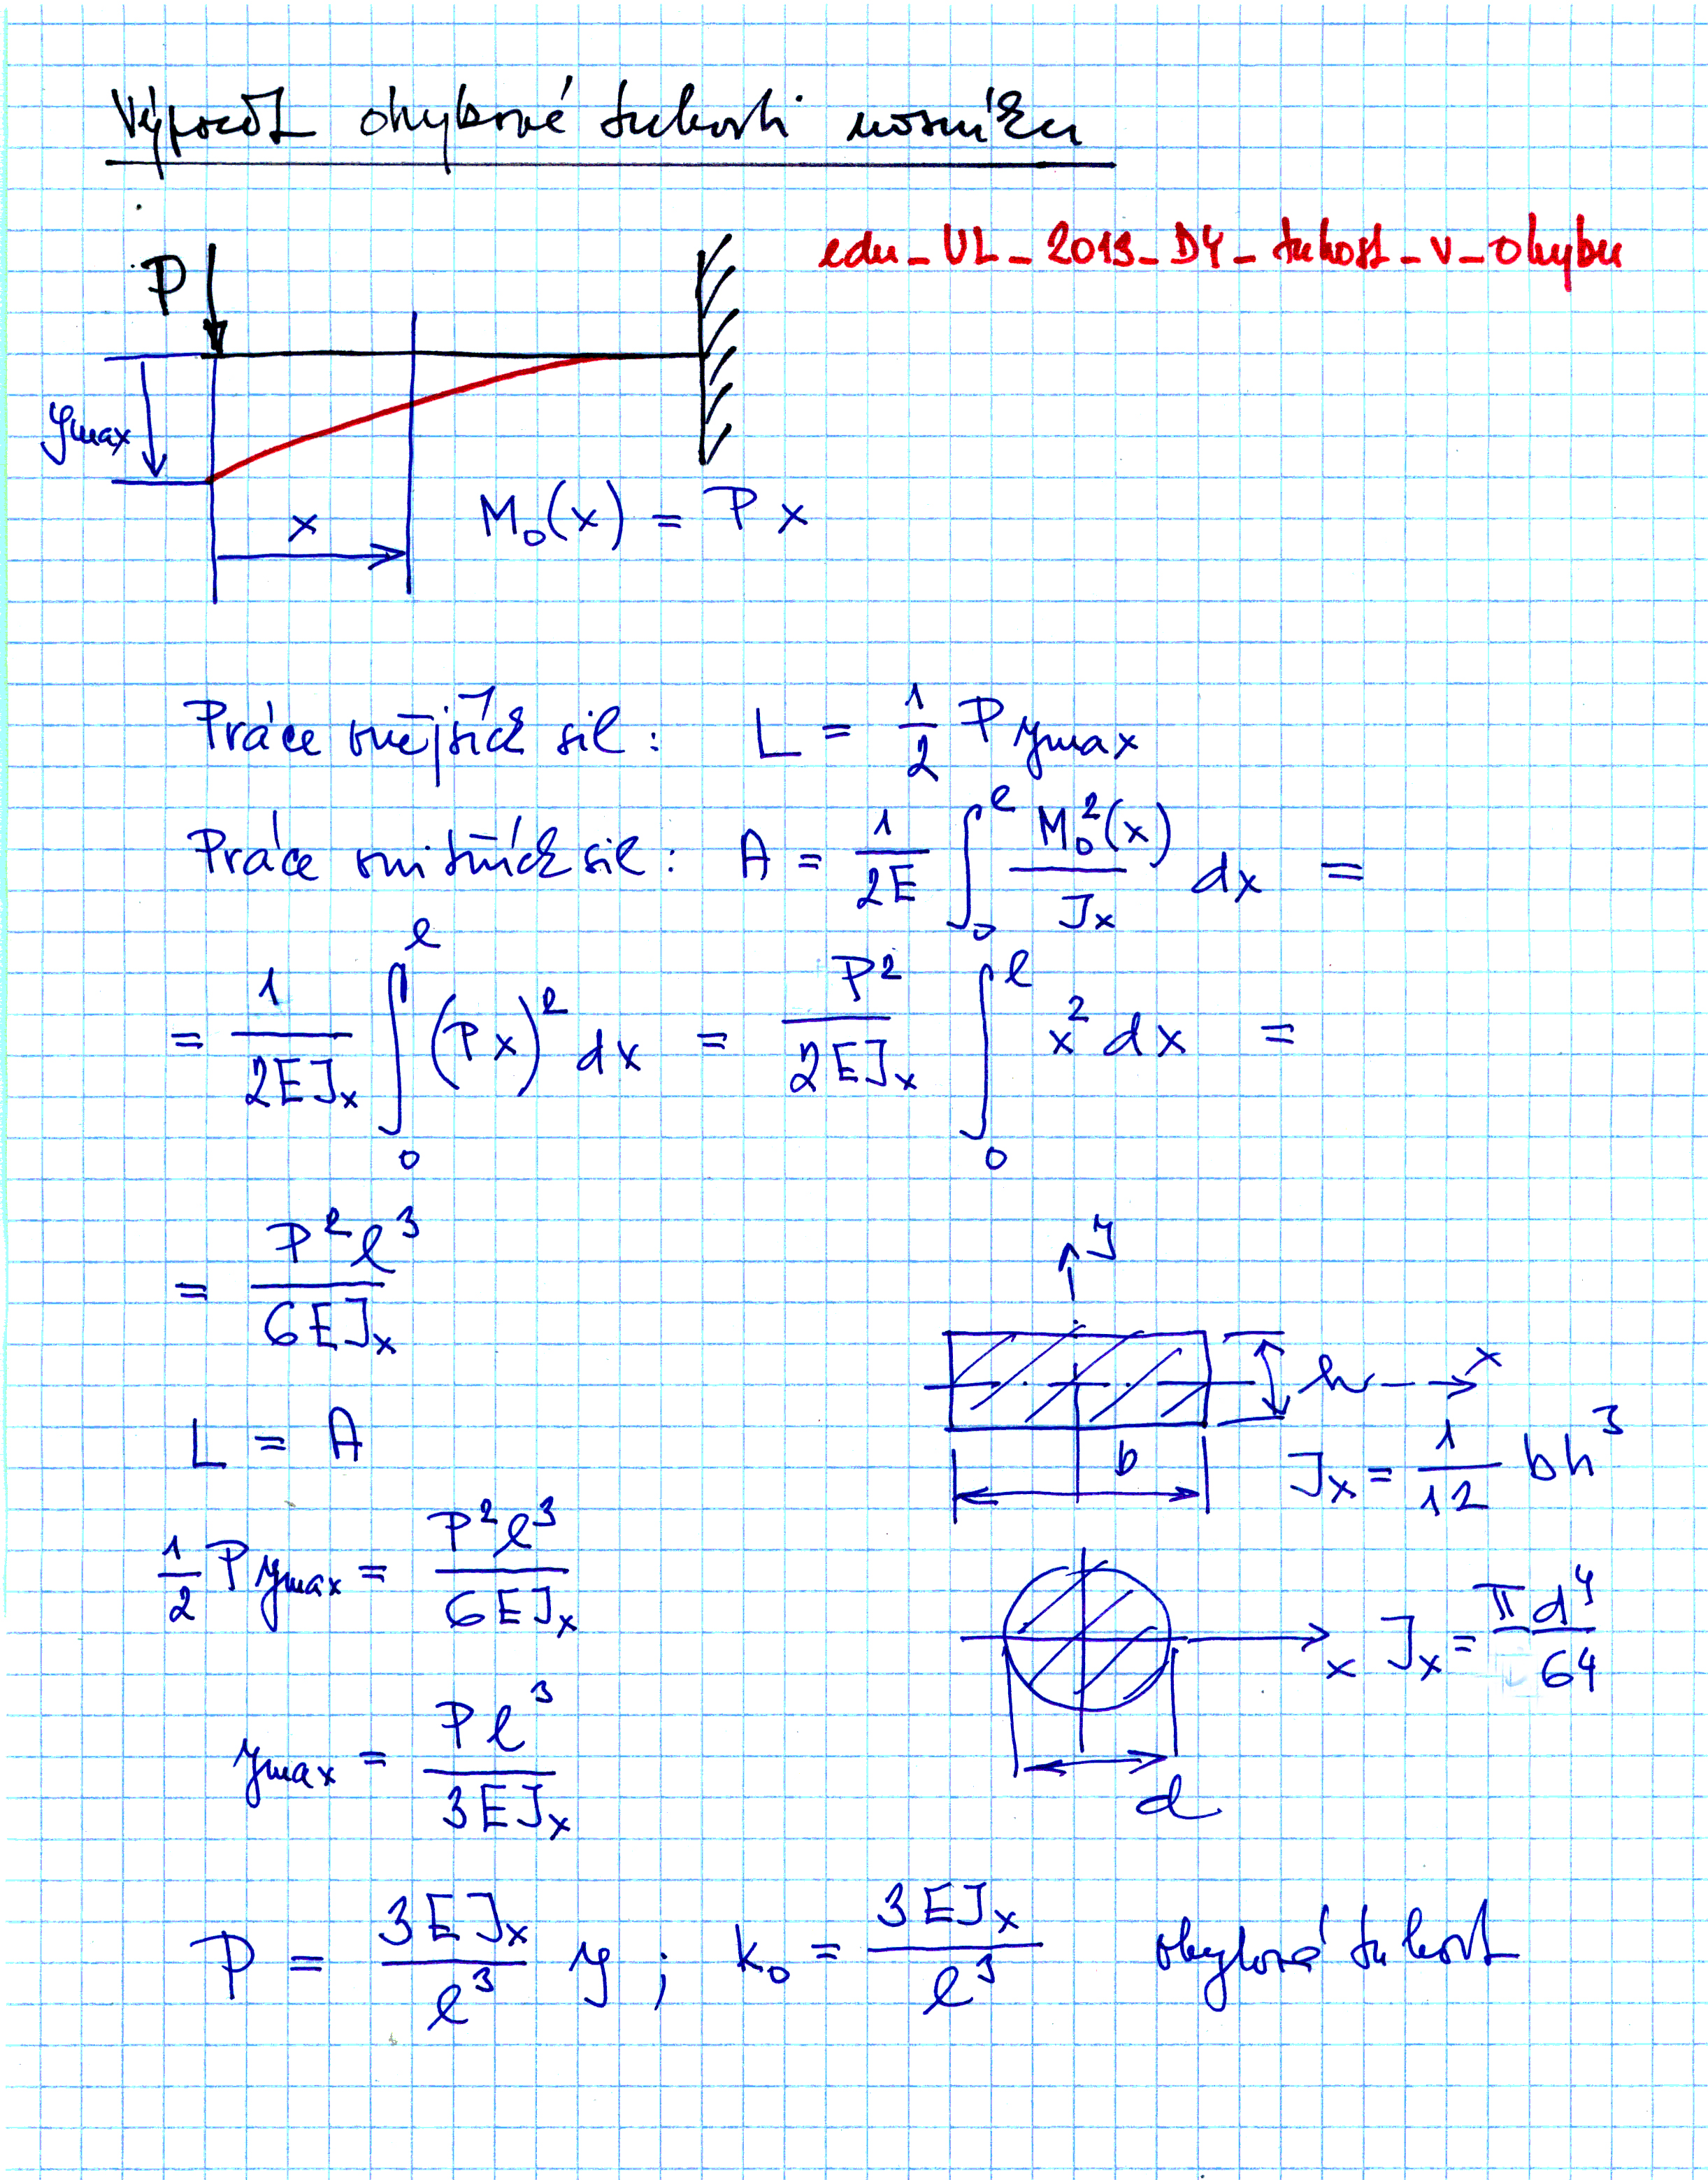

External forces >>

Internal forces >>

Bending stiffness

